Old Mother Shipton Shuffle
The Important Stuff:
Distance | Registration Open | Race Brief (start line) | Race Start
Ultra-Marathon | 8:00 – 9:15 | 9:20 | 09:30
Marathon | 8:00 – 9:15 | 9:20 | 09:30
20 Miles | 8:00 – 9:15 | 9:20 | 09:30
½ Marathon | 9:15 – 10:15 | 10:20 | 10:30
10k | 10:15 – 11:45 | 11:50 | 12:00

GETTING TO US:
All races start in the park opposite Mother Shipton Cave, you will see a yellow sign stating RACE HQ – The post code for Mother Shipton Cave is HG5 8DD.
You cannot park at the start/finish area but you can park over the Bridge in Conyngham long stay carpark, council charges apply. The address is:
Conyngham Car Park
Bond End
Knaresborough
HG5 9AY
Race Numbers and Registration (and loos):
All registration will take place in the park opposite Mother Shipton Cave, you will see our lovely gazebo.
Please don’t leave it to the last minute to collect your numbers we want everyone to enjoy their day and stressing in a queue minutes before the race isn’t a great start.
You can drop your bag at the start and finish area.
Toilets are available in Conyngham Car Park.
THE COURSES
Detailed maps are further down the brief.
The route is undulating. The route is mainly on good path, private road, disused railway track and 150 yards of field, the field could become very muddy if there has been a lot of rain beforehand but it is only a very short stretch of field.
RUNNING SHOES
I would recommend Road Shoes, the course is mainly solid underfoot.

NUMBER EXCHANGE, withdrawal, deferrals, refunds, changes on the day entries.
We have hundreds of entrants to manage on race day and whilst we want you all happy things invariably get hectic at Grim HQ, as a result:
We cannot issue refunds, or defer your entry without 2 weeks’ notice – with the number of races and the effort going into each event it’s just not possible.
We want to try and do everything we can to get you running and so we ask that you also give us two weeks’ notice if you want to transfer your place to another runner or change the distance you are running. However we will TRY to accommodate some of these changes on race day. This will be at the committee’s discretion and numbers will be released 30 mins before race start. This cannot be confirmed beforehand as it is dependent on a number of factors.
There may be a number of entries on the day. This will be at the committee’s discretion and numbers will be released 30 mins before race start. This cannot be confirmed beforehand as it is dependent on a number of factors. You will be excluded from a top three award.
We hope to have a ‘Change and On the Day’ desk, due to limited volunteers there will only be one person staffing that desk so it could get busy and we’d hate you to be late for your race.

BAG DROP
There will be a drop at the start finish. Bags and property left at your own risk, we will keep an eye on it but can’t promise.

RACE TIMES
All races will start at the above times.

DURING THE RACE
We hope to start all the races promptly. Please inform a race official if you are unable to complete the course and need to withdraw for any reason. Please assist officials by making sure your number is visible.
We don’t own the race path on the day please be courteous to other users, smile and try to keep left. The path should easily be wide enough for everyone to use it and we are staggering the starts to prevent congestion.
There is a 6 hours 30 mins cut off for support on the runs. If you think you will take longer than 6 hours 30 mins then you can arrange to start early but the marshals will stand down assuming a 6 hours 30 mins runner. If you think you may take longer then:
- Let us know prior to the event, we can then arrange to set you off early.
- Carry your own food, water, warm, spare clothing, and charged mobile phone.
We do not want to spoil the enjoyment of the event for the competitors but we do not endorse the use of I pods or similar devices (bone conduction headphones can be used) for the following safety reasons:
Runners cannot always hear the marshals’ instructions.
Runners may not hear cyclists behind them and stray into their path.

WATER
We are going cup free in 2019 – please help us by bringing your own re-usable cups and/or drink bottles.
Jugged water and squash will be available at all drinks stations, there will also be food on the course. Water will be available approx. every 3 miles and at the start/finish. You may place your own drinks, gels etc. at the water stations, please mark them clearly with your name. Bottled water is available at the end.
Please don’t litter, we run in beautiful locations and it’s always a shame that we have to pick up cups and gel wrappers after every event, have a stern word with yourself.
WEATHER AND CLOTHING
Please keep an eye on the forecast and dress appropriately. We love you and only want the best for you, so, if it’s minus three, snowing and you are dressed in vest and shorts we probably won’t be letting you start. Similarly sun cream is always wise in sunny weather.
SOCIAL vs E-Mail.
Well, we are a very social little group and we love our Twitter and Facebook, there is also a Facebook chat group where you can ask questions such as what trainers to wear, what’s the elevation like, any tips, recommendations, all from other runners as well as ourselves or if you just want to chat, we really recommend you use this rather than messaging/emailing in, as most of the time the query can be resolved on there. At times we get inundated with emails and messages asking the same questions which ties us up and means we can’t deal with things that need dealing with like permits, new race routes and baking cakes and fudge etc.

We really do understand your races are important days to you. We love seeing smiles and watching runners enjoying themselves, that’s why we do it! Please just help us to help you.

The Courses – All routes are available on its Grim up North Strava.
10k x 1 loop
Half Marathon 2 x loops
20 Miler x 3 loops
Marathon x 4 loops
Ultra x 5 loops, Yikes……

The 10k Loop
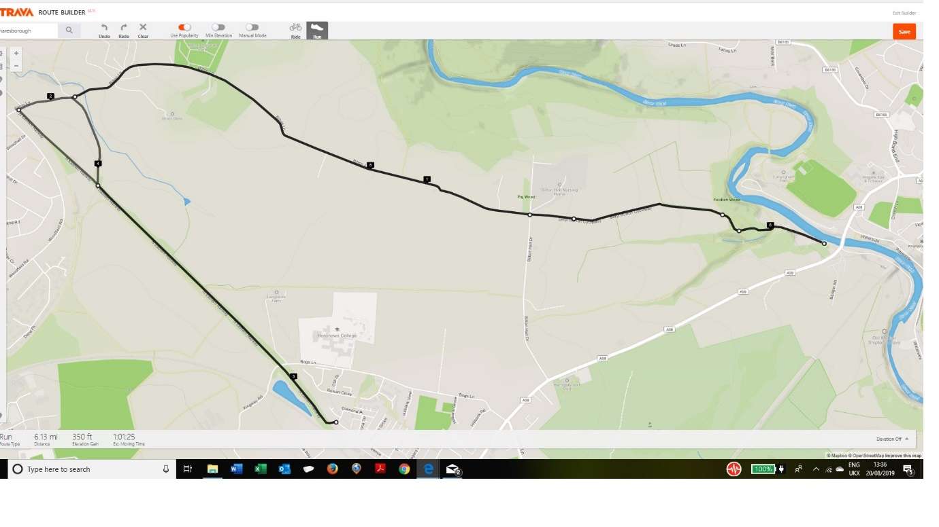

6.55 Mile Loop
